

American International University- Bangladesh

CSC 4261: Advanced Programming in Web Technology

CO1 Evaluation

Project Report

SPRING 23-24

Project Title: University Management System

Project Domain: Management System

Group Number: 8

Section: C

|  |  |
| --- | --- |
| Student Name | Student Id |
| SAAD, TOUHIDUL ISLAM | 22-46996-1 |

1. **Introduction:**

This project aims to modernize university operations, facilitating seamless student enrollment, efficient faculty management, and streamlined administrative tasks. By leveraging NestJS technology, it promises scalability, security, and flexibility, ensuring a robust system to meet the evolving needs of higher education institutions.

1. **Problem Analysis:**

**Problem Statement:**

Universities grapple with managing a multitude of complex administrative tasks, often relying on manual processes, disparate systems, and paper-based records.

Repetitive tasks cause time-consuming administrative tasks in the traditional admissions, enrollment, and grade management system. Producing accurate evaluations is difficult due to gaps in information and errors. Traditional methods also hinder faculty, staff, and student collaboration and communication, which delays important tasks. Human error can also occur in manual processes.

**Significance of Solving the Problem:**

A University Management System (UMS) built with NestJS addresses these challenges by:

* **Streamlining Workflows**: Automating repetitive tasks frees up staff time to focus on more strategic initiatives and student support.
* **Centralized Data Management**: A unified platform consolidates student records, course information, financial data, and more, ensuring accuracy and accessibility.
* **Enhanced Communication and Collaboration**: Secure portals facilitate interaction between faculty, staff, and students, fostering a more collaborative learning environment.
* **Improved Decision-Making**: Real-time data insights empower universities to make informed decisions regarding resource allocation, curriculum development, and student success initiatives.
* **Reduced Costs and Increased Efficiency**: Automated workflows and centralized data management minimize administrative overhead and operational costs.

**Existing Solutions:**

Several UMS solutions address these needs:

* **Blackboard Learn**: Offers a comprehensive learning management system (LMS) with course management, communication tools, and assessment capabilities. [blackboard.com].
* **Banner by Ellucian**: An enterprise resource planning (ERP) system for higher education, covering student administration, finance, human resources, and more [ellucian.com].
* **Canvas LMS**: Another popular LMS providing course creation, collaboration features, and mobile access for students [instructure.com/canvas].
* **Oracle PeopleSoft Campus Solutions**: An integrated suite for student lifecycle management, financial aid, and human capital management [[docs.oracle.com/en/applications/peoplesoft/campus-solutions/index.html](https://docs.oracle.com/en/applications/peoplesoft/campus-solutions/index.html)].

1. **Feature Analysis:**
2. **User Category:**
3. Beneficiary user:
4. Admin
5. **Feature List:**

In this project the “*Beneficiary (Admin)*” has the following features:

* + SignUp
  + LogIn
  + Index
  + LogOut
  + Send Mail
  + Upload Files
  + List of all files [fetching]
  + Get file by name [fetching]
  + Upload Excel file to get CSV file
  + One-to-one relationships with Trustee [adding & removing]
  + One-to-many relationships with Office and Directory [adding & removing]

**4. Design:**

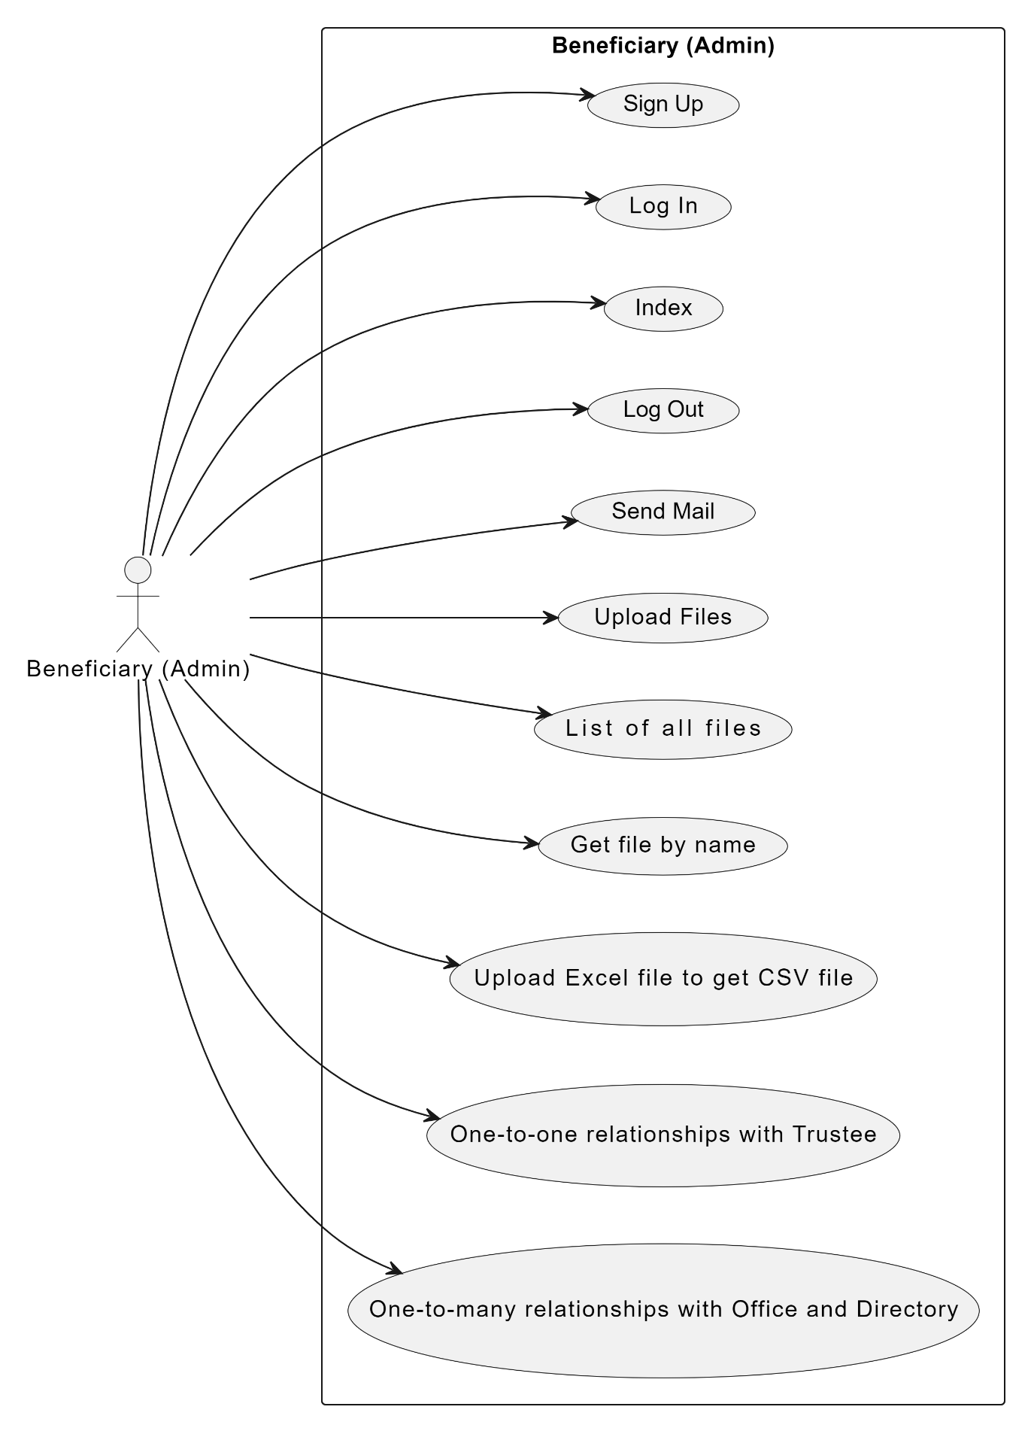

**Figure 1: Use Case Diagram**

**Figure 2: ER Diagram**

**5. Tools Used:**

To develop this project, we have used the following:

* + Visual studio code
  + Postman
  + pgAdmin 4

**6. System Images against the Specification:**

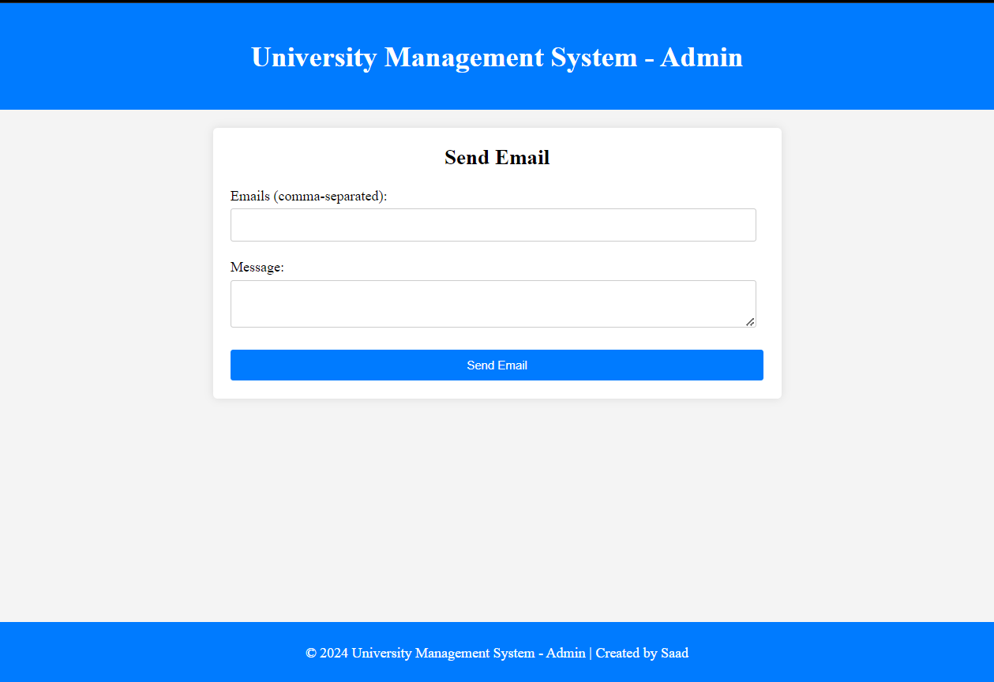

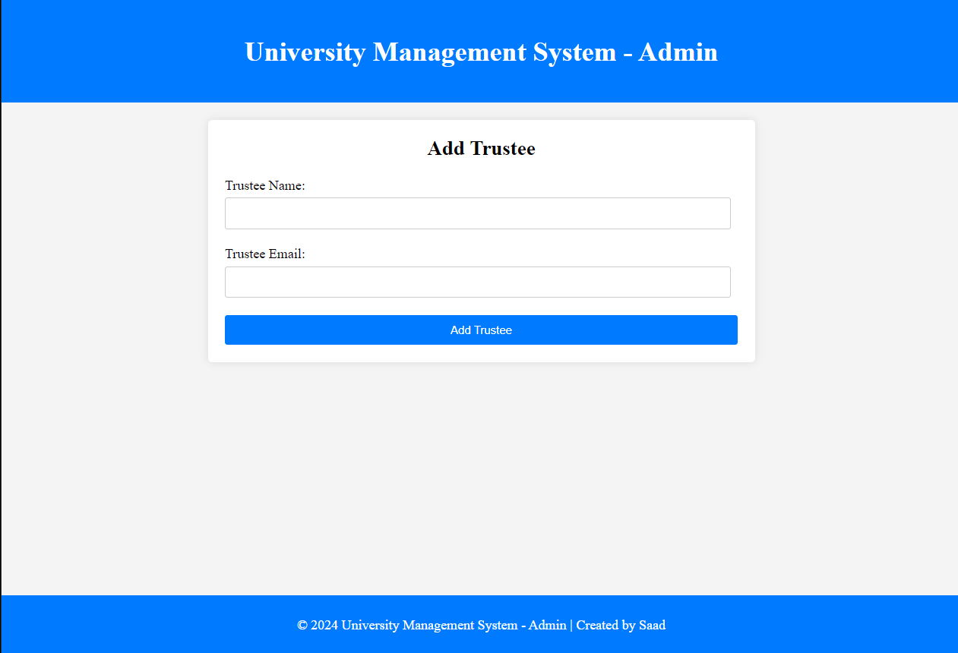

**7. Impact of this Project:**

In modern society, the "University Management System" project is crucial for fostering efficient academic institutions, enhancing learning experiences, and promoting educational excellence. By streamlining operations and facilitating seamless communication, it empowers students, faculty, and administrators to thrive in a dynamic educational environment.

**Benefits:**

* Enhanced operational efficiency
* Improved communication and collaboration
* Enhanced academic experiences for stakeholders

**8. Limitations and Possible Future Improvements:**

Limitations may include initial implementation costs, user adoption challenges, and potential technical constraints. Future improvements could focus on integrating advanced analytics for data-driven decision-making, enhancing user interfaces for greater accessibility, and expanding interoperability with other systems to optimize functionality and user experience.

|  |  |  |  |
| --- | --- | --- | --- |
| CO1 Evaluation: Project Report Evaluation | | | |
| Problem  Analysis  (5) | Use Case  Diagram  (5) | ER  Diagram  (5) | Total (15) |
|  |  |  |  |
|  | | | |